PYTHON ACTIVITY BASED LEARNING
PROBLEM 2
Problem Statement:
Progressive Electricity Billing System
1. Objective
To develop a Python program that calculates household electricity bills using progressive consumption slabs, fixed charges, surcharges, and rebates. The program compares bills across several months and identifies unusual increases in electricity charges.
2. Program (Python)
# Progressive Electricity Billing Systemmonths = ["January", "February", "March", "April"]units_list = [100, 150, 180, 300]fixed_charge = 50surcharge_rate = 0.05rebate_rate = 0.10bills = []for units in units_list: # Calculate charges using progressive slabs if units <= 100: energy_charge = units * 2 elif units <= 200: energy_charge = 100 * 2 + (units - 100) * 3 else: energy_charge = (100 * 2 + 100 * 3 + (units - 200) * 5) surcharge = energy_charge * surcharge_rate rebate = energy_charge * rebate_rate if units < 150 else 0 total = energy_charge + fixed_charge + surcharge - rebate bills.append(total)print("Monthly Electricity Bills")print("--------------------------")for i in range(len(months)): print(months[i], ":", round(bills[i], 2))print("\nUnusual Bill Increases (> 30%)")for i in range(1, len(bills)): increase = bills[i] - bills[i - 1] percentage = (increase / bills[i - 1]) * 100 if percentage > 30: print(months[i], "- Increase:", round(percentage, 2), "%")
3. Algorithm
- Start.
- Initialize the monthly electricity consumption values.
- Set the fixed charge, surcharge rate, and rebate rate.
- Read the consumption for each month.
- Calculate energy charges using progressive slabs:
  - First 100 units: ₹2 per unit.
  - Next 100 units: ₹3 per unit.
  - Above 200 units: ₹5 per unit.
- Calculate the surcharge and applicable rebate.
- Calculate the total bill by adding energy charges and fixed charges, then adding the surcharge and subtracting the rebate.
- Store the total bill for each month.
- Compare each month's bill with the previous month's bill.
- Calculate the percentage increase.
- If the increase exceeds 30%, display an unusual increase alert.
- Display all monthly bills and alerts.
- Stop.
Flowchart
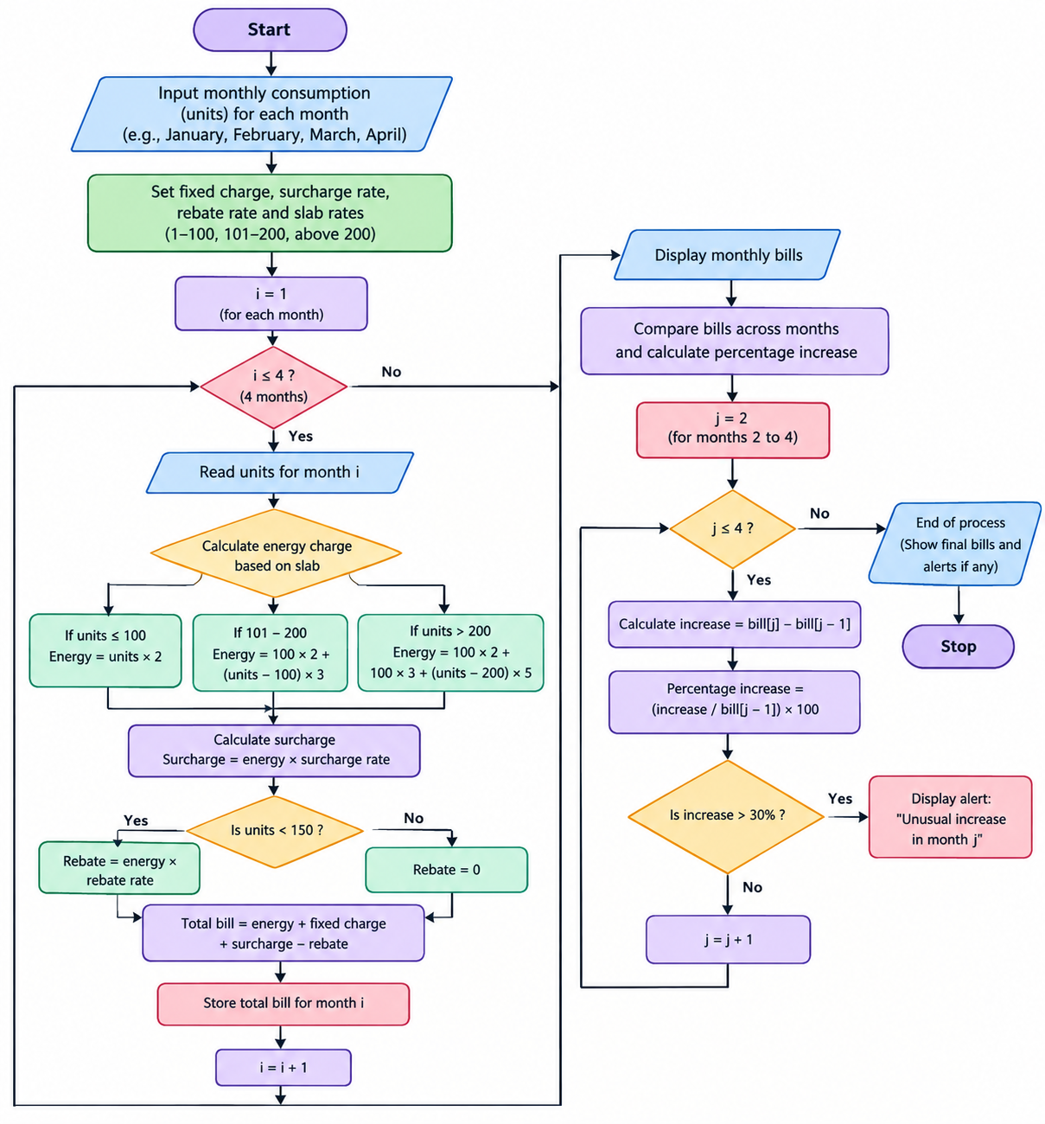
4. Pseudocode
BEGIN
months = January, February, March, April
units = 100, 150, 180, 300

fixed_charge = 50
surcharge_rate = 5%
rebate_rate = 10%

FOR each month
IF units <= 100
energy = units * 2
ELSE IF units <= 200
energy = 100 * 2 + (units - 100) * 3
ELSE
energy = 100 * 2 + 100 * 3
+ (units - 200) * 5
END IF

surcharge = energy * 5%

IF units < 150
rebate = energy * 10%
ELSE
rebate = 0
END IF

bill = energy + fixed_charge
+ surcharge - rebate
STORE bill
END FOR

DISPLAY all monthly bills

FOR each month from the second month
increase = current bill - previous bill
percentage = increase / previous bill * 100

IF percentage > 30
DISPLAY unusual increase alert
END IF
END FOR
END
5. Output
Monthly Electricity Bills
--------------------------
January : 239.5
February : 365.0
March : 459.5
April : 1025.0

Unusual Bill Increases (> 30%)
February - Increase: 52.4 %
March - Increase: 25.89 %
April - Increase: 122.96 %
Result
The program calculates electricity bills using progressive slabs, fixed charges, surcharges, and rebates. It compares monthly bills and flags increases greater than 30%, helping households identify unusual changes in electricity expenses.

